**Journal Report 22**

**02/16/2024**

The main hyperparameter I was testing was input_chunk_length. My grid searching algorithm finished faster than expected so I was able to get some results. Essentially, I learned that the values don’t change much in the range of 0 - 100. The graph below shows that smaller input_chunk_length values don't quite reflect the relationship of the expected behavior. Specifically, I noticed that the larger the input_chunk_length, the more overfitting is present within the forecasts. To make any meaningful changes within the forecast, it seems that the values need to be in the range of 300 - 700. As a result, I started another batch of grid searching, but this time with increments of 100. In other words, my for loop looked like this:

for i in range(300, 700, 100)

I will check the results for this new grid search by Wednesday.

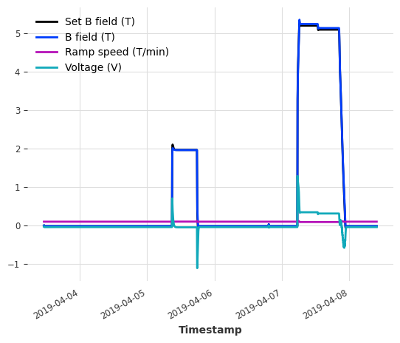

**02/19/2024**

Resuming my work from last Wednesday, I did some further research on the methods to properly annotate anomalies within the time series. I did some more research and the quickest solution seems to be to create another time series that denotes each timestamp with a 1 or 0. A 1 represents anomalous data and a 0 represents “normal behavior.” I started this process on my dataset. I am aiming to first label three time series with these anomaly scores. Then, I will train an anomaly threshold model as my first minimum viable product. Afterward, I will explore more unsupervised methods.

**02/21/2024**

I did some more hyperparameter tuning. Continuing from my work from last Friday, I found the pattern that you can offset overtraining from a larger input_chunk_length by increasing the output_chunk_length. This hyperparameter essentially controls how generalizable the model is, but the tradeoff is that the forecasts are smaller than the actual values. I am creating code to optimally find the best hyperparameter values for these two and will run it on Friday to see the results. My most optimal result so far is depicted by the graph on the left below and compared to what it should be on the right. The model is instantiated with these hyperparameter values:

model = RNNModel(input_chunk_length=200, output_chunk_length=100, n_epochs=10)

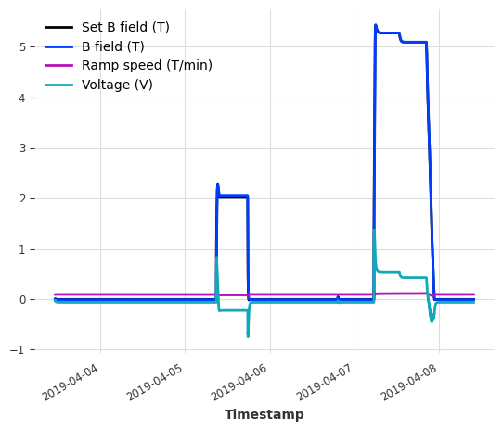 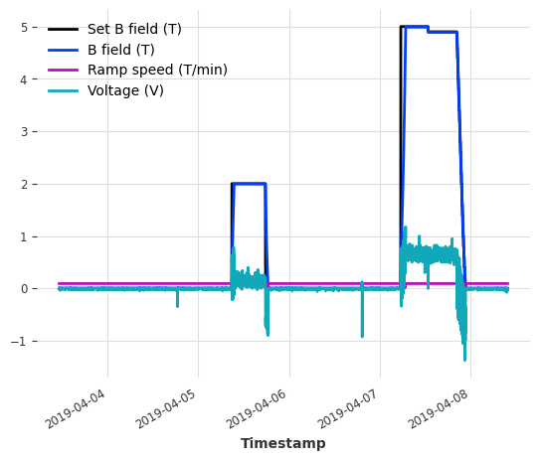

On the other hand, the new grid search that ran for larger input_chunk_length values on Wednesday showed that there were better forecasts but overfits tremendously.